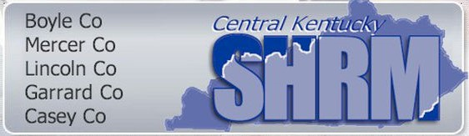
Dear Potential CKSHRM Member,
On behalf of the Board, I would like to formally invite you to become a member of Central Kentucky Society for Human Resource Management, a SHRM affiliate. You qualify for this exclusive privilege based on your experience and commitment to the HR profession.
Our organization is an indispensable resource for Human Resource professionals throughout the region. Our members represent individuals who recognize the importance of our professional affiliation for staying current on HR changes and trends and networking. As a member, you will be able to continue your professional development, grow your contacts and collaborate with others with similar challenges.

Joining is easy visit www.ckshrm.org and click join now or complete the below and submit payment.

We look forward to welcoming you to our chapter community.
Sincerely,
Joanne Prewitt
President Elect/Membership Chair
P.S. Our first meeting is in February
MEMBERSHIP APPLICATION Total Due: $60 National Member $85 Non-National Member
Payment Method: (circle) Check Cash Card/PayPal
Full Name: ________________________________________________________ Title: ______________________________
Company Name: ______________________________________________________________________________________
Address: ________________________________ City: _______________________ State: ______ Zip code:________
E-mail Address:________________________________________________________
Phone number:________________________________________________________
National SHRM member identification number: _________________________________
Certification: (circle) PHR SPHR SHRM-CP SHRM-SCP
Regular Member:
 |  | 50% or more of your time is devoted to human resource activities
 |  | Principal person responsible for human resource activities, but less than 50% of your time is devoted to those activities
 |  | Faculty member in human resource management or specialized phase of personnel at an accredited college or university
Affiliate Member:
 |  | None of the above, but work in a closely related field and have an interest in the purposes of CKSHRM
 |  | Field work in: |  |  |  |  |  |  |  |  |  |  |  |  |  | For profit:
 |  | State nature of interest in CKSHRM:
Student Member:
 |  | Full-time student in accredited college or university with a bona-fide interest in human resource management
 |  | College: |  |  |  |  |  |  |  |  |  |  | Major:
 |  | State nature of interest in human resource management:
MEMBERSHIP RESPONSIBILITIES: (find at www.ckshrm.org)
 |  | I have read and agree to abide by the Code of Ethics
 |  | I have read and agree to abide by the current Bylaws
PayPal or Check
CHECK made payable to: CKSHRM
Mail this completed form with payment to:
CKSHRM POB 2326 Danville Kentucky 40423-1753 or email to jprewitt@nescoresource.com with PayPal payment

CKSHRM Board Approval Signature: ________________________________________Date: _________________________

